## Assignment on unstructured database

## Name : Kaveri Zanzane

## Roll no : 242

**STATEMENT:**

Design unstructured database and perform insert, update, delete operations on it. Apply commands like count( ), limit( ),sort( ) , find on the database. Use operators like $gt, $lt,$in, etc

**Insert:**

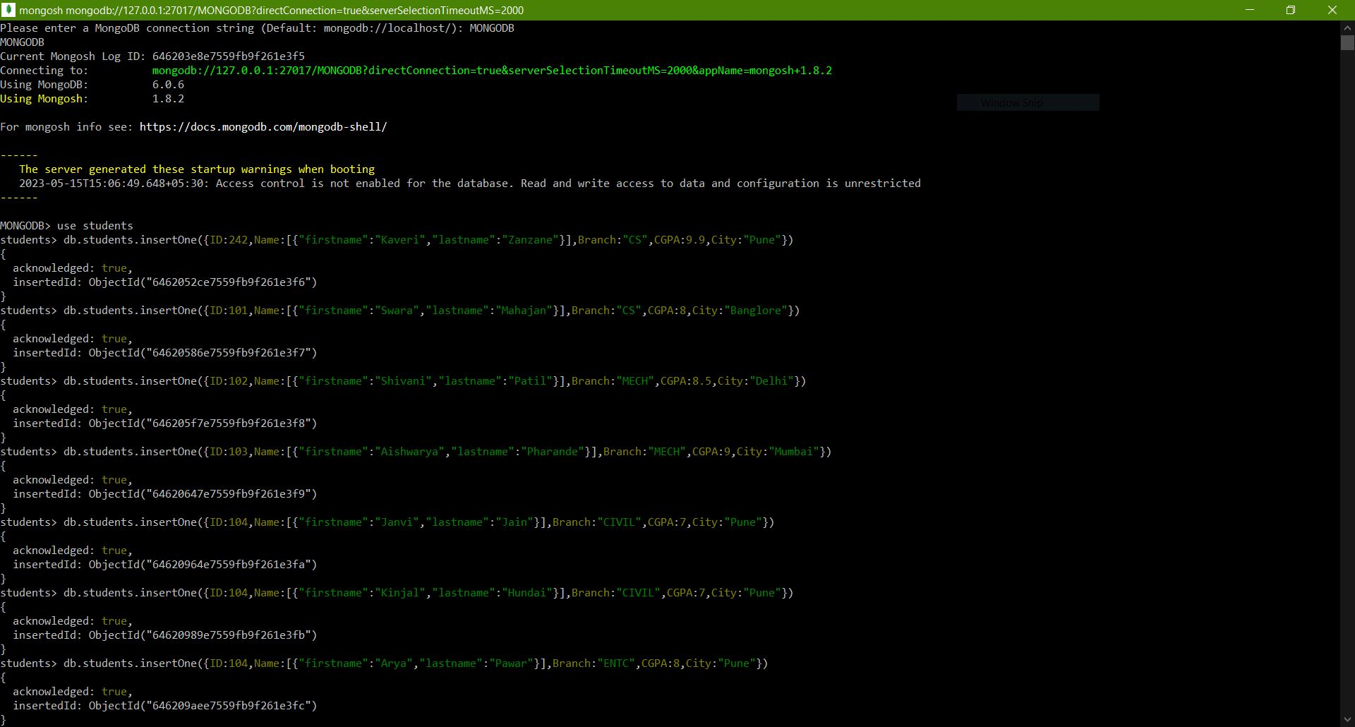

**Find():**

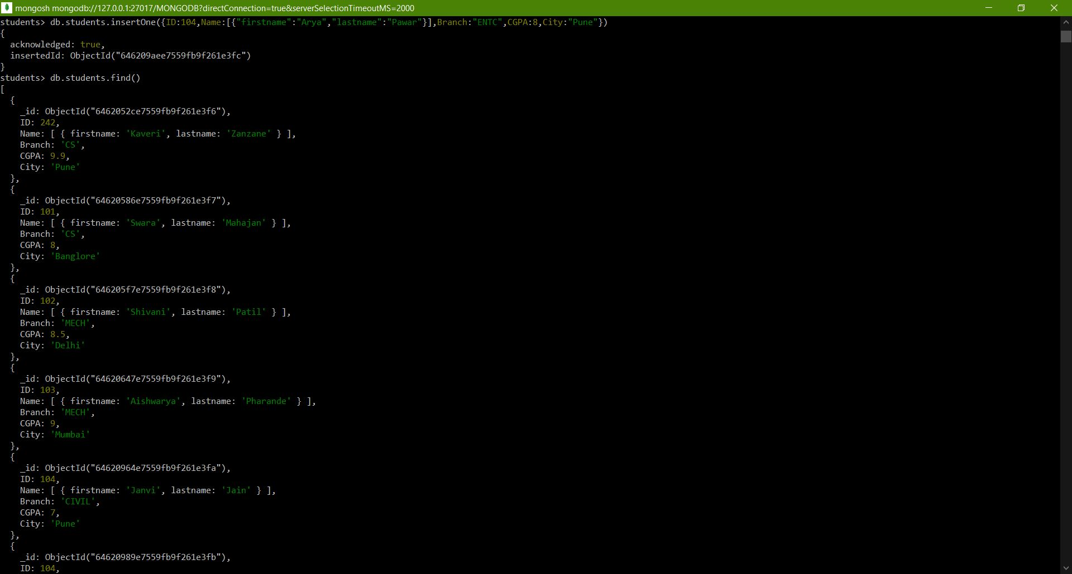

**Delete():** DeleteOne() & DeleteMany()



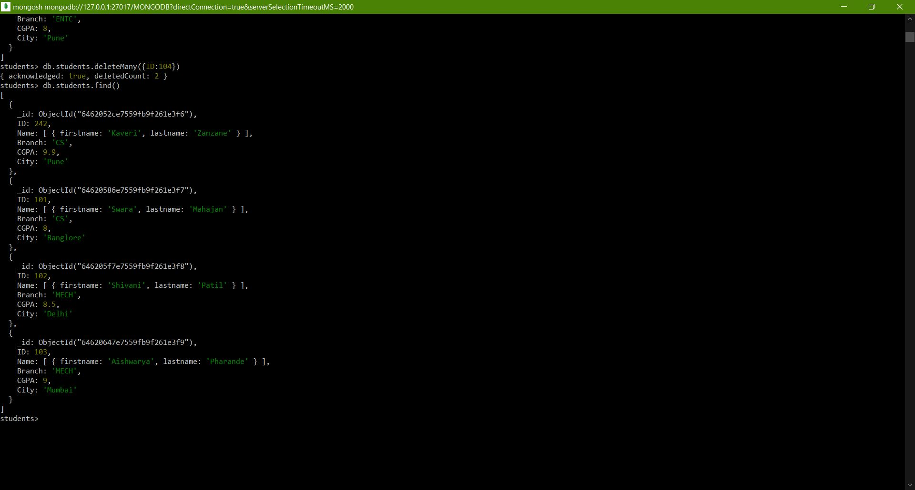

**Update():**UpdateOne()

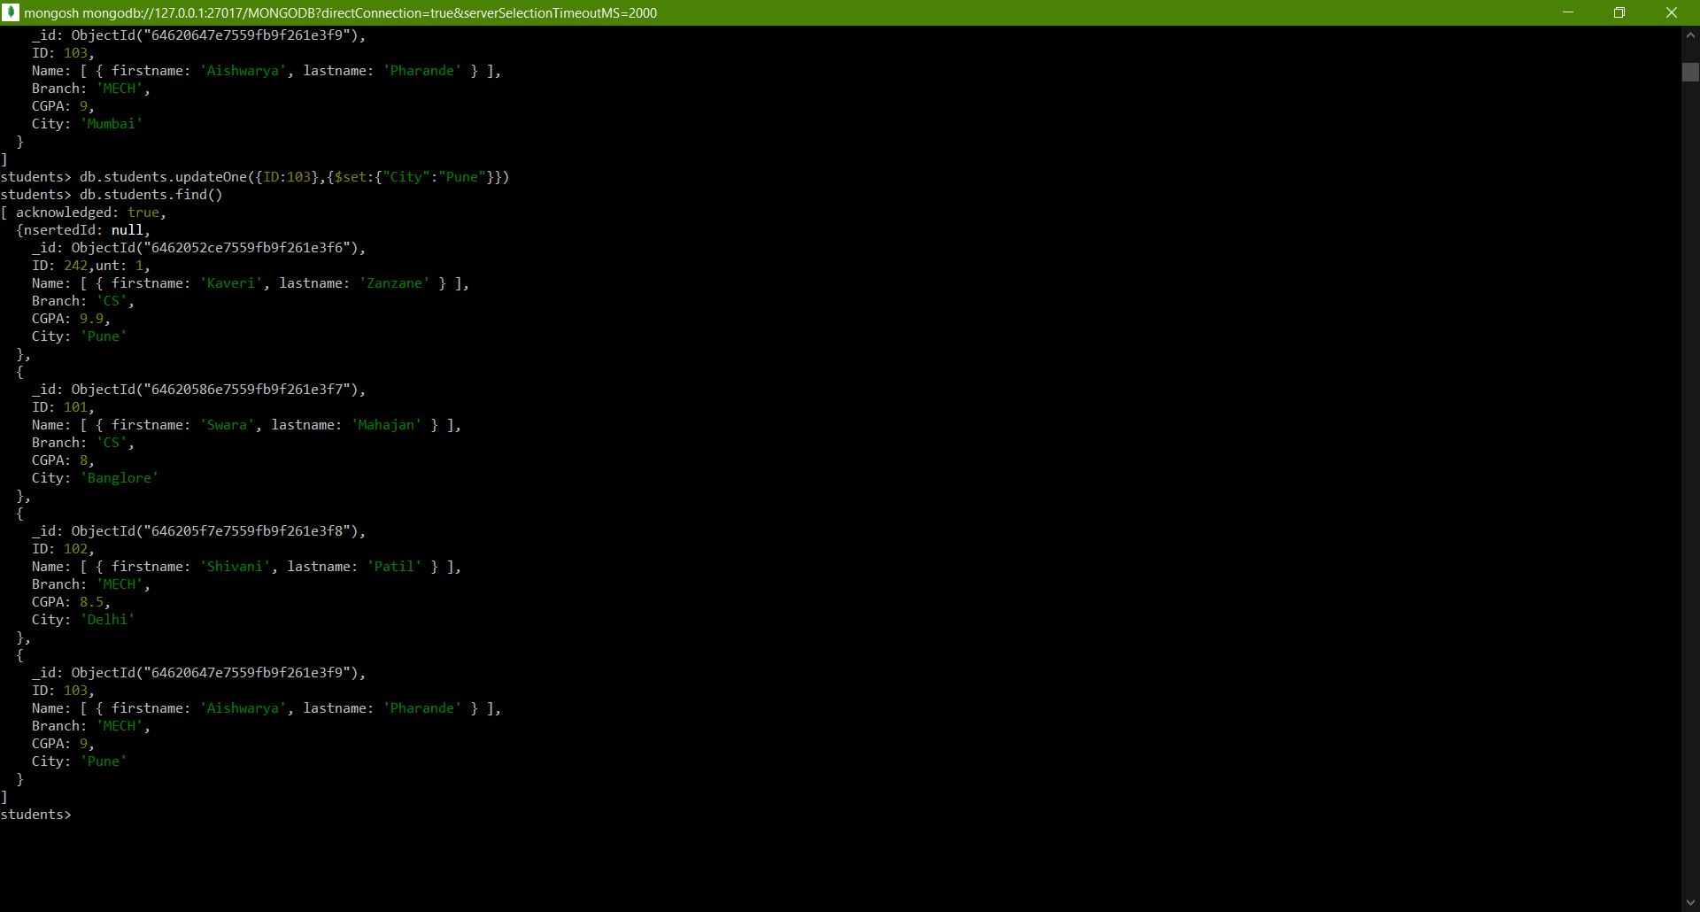

**$gt, $lt:**

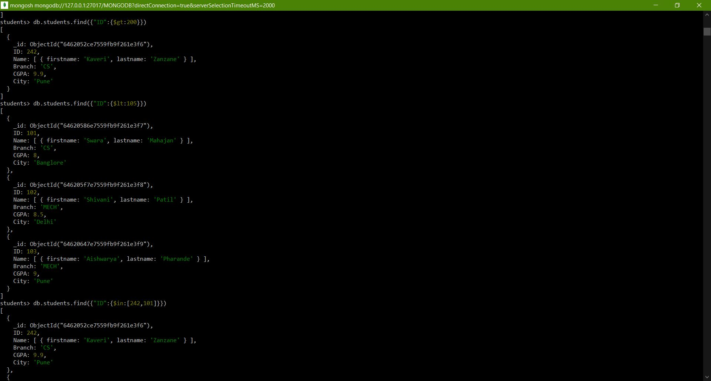

**Sort() ,Agrregate() & Limit():**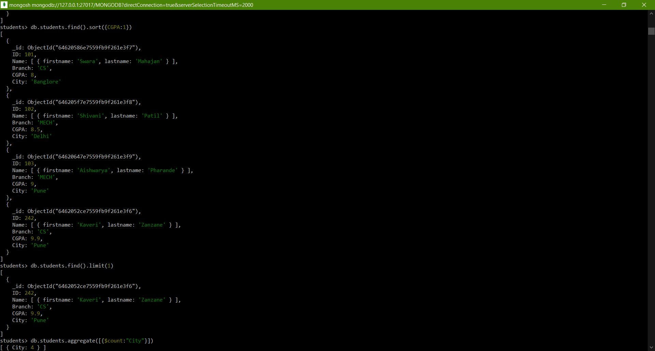

**$in** **:**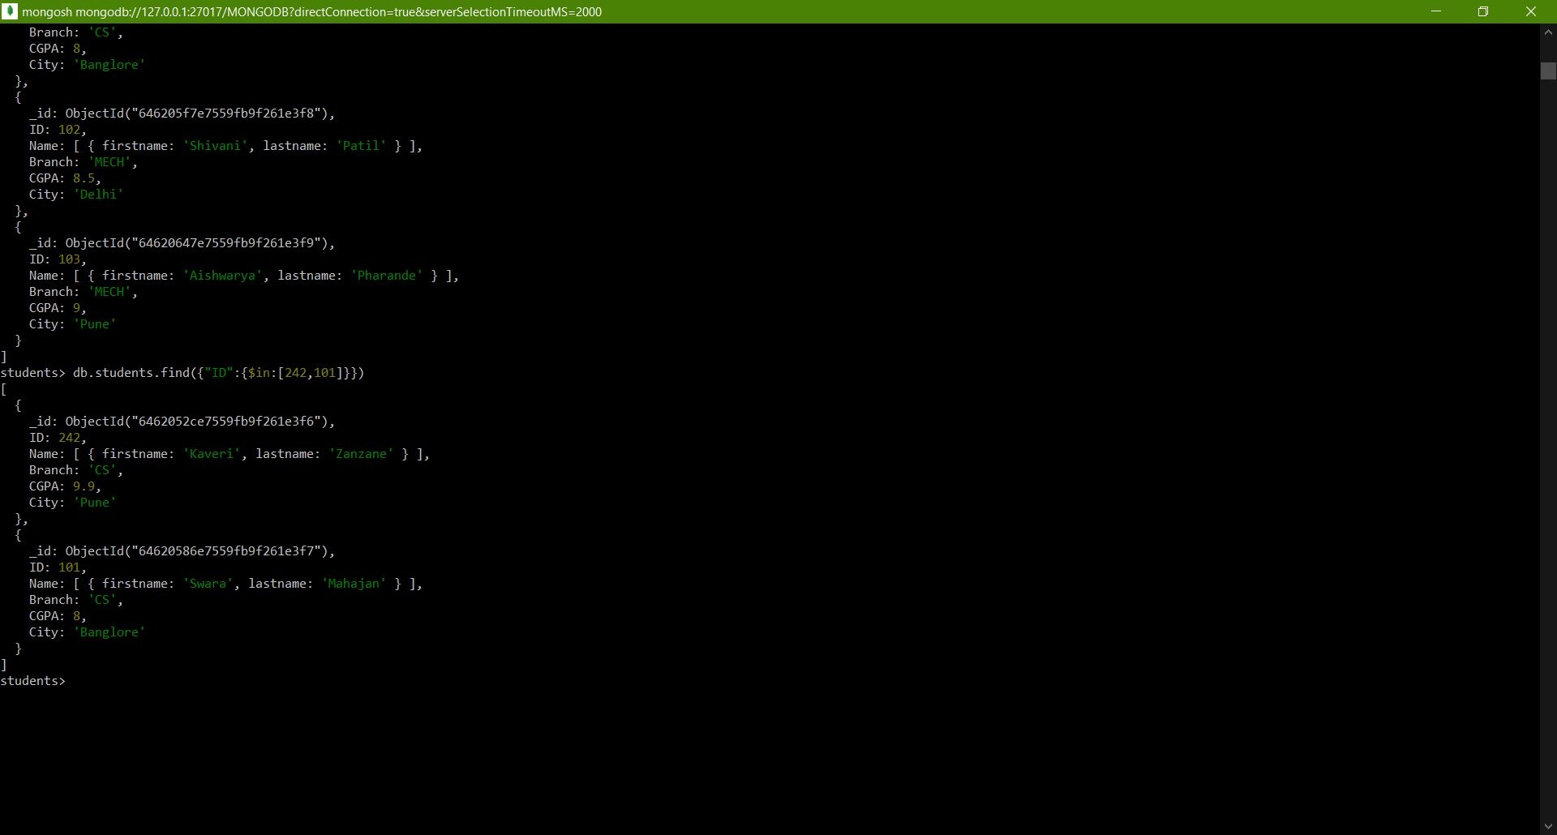 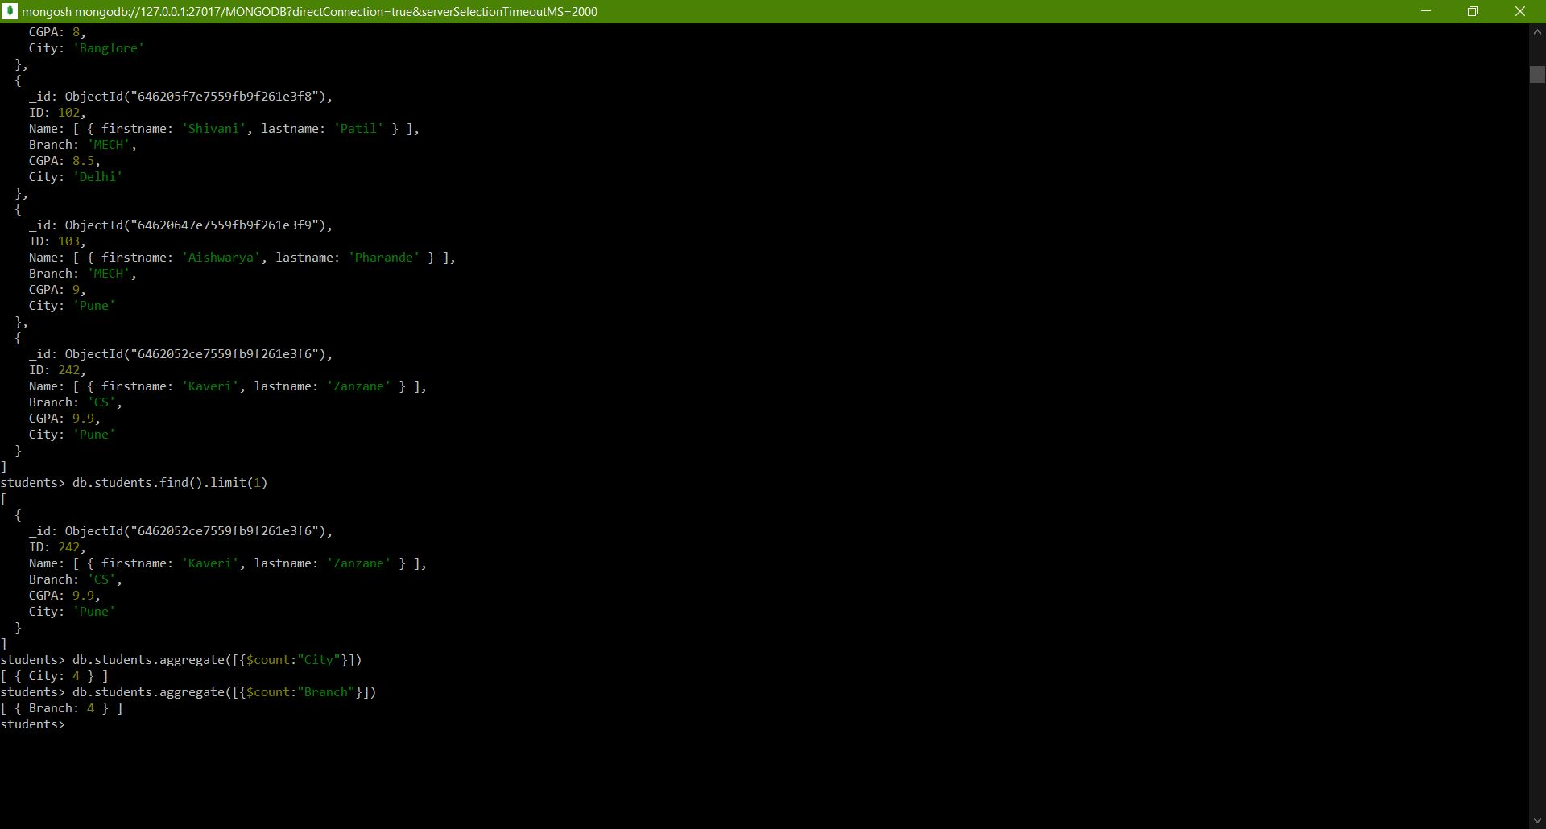

**Commands:**

MONGODB> use students

students> db.students.insertOne({ID:242,Name:[{"firstname":"Kaveri","lastname":"Zanzane"}],Branch:"CS",CGPA:9.9,City:"Pune"})

{

acknowledged: true,

insertedId: ObjectId("6462052ce7559fb9f261e3f6")

}

students> db.students.insertOne({ID:101,Name:[{"firstname":"Swara","lastname":"Mahajan"}],Branch:"CS",CGPA:8,City:"Banglore"})

{

acknowledged: true,

insertedId: ObjectId("64620586e7559fb9f261e3f7")

}

students> db.students.insertOne({ID:102,Name:[{"firstname":"Shivani","lastname":"Patil"}],Branch:"MECH",CGPA:8.5,City:"Delhi"})

{

acknowledged: true,

insertedId: ObjectId("646205f7e7559fb9f261e3f8")

}

students> db.students.insertOne({ID:103,Name:[{"firstname":"Aishwarya","lastname":"Pharande"}],Branch:"MECH",CGPA:9,City:"Mumbai"})

{

acknowledged: true,

insertedId: ObjectId("64620647e7559fb9f261e3f9")

}

students> db.students.insertOne({ID:104,Name:[{"firstname":"Janvi","lastname":"Jain"}],Branch:"CIVIL",CGPA:7,City:"Pune"})

{

acknowledged: true,

insertedId: ObjectId("64620964e7559fb9f261e3fa")

}

students> db.students.insertOne({ID:104,Name:[{"firstname":"Kinjal","lastname":"Hundai"}],Branch:"CIVIL",CGPA:7,City:"Pune"})

{

acknowledged: true,

insertedId: ObjectId("64620989e7559fb9f261e3fb")

}

students> db.students.insertOne({ID:104,Name:[{"firstname":"Arya","lastname":"Pawar"}],Branch:"ENTC",CGPA:8,City:"Pune"})

{

acknowledged: true,

insertedId: ObjectId("646209aee7559fb9f261e3fc")

}

students> db.students.find()

[

{

_id: ObjectId("6462052ce7559fb9f261e3f6"),

ID: 242,

Name: [ { firstname: 'Kaveri', lastname: 'Zanzane' } ],

Branch: 'CS',

CGPA: 9.9,

City: 'Pune'

},

{

_id: ObjectId("64620586e7559fb9f261e3f7"),

ID: 101,

Name: [ { firstname: 'Swara', lastname: 'Mahajan' } ],

Branch: 'CS',

CGPA: 8,

City: 'Banglore'

},

{

_id: ObjectId("646205f7e7559fb9f261e3f8"),

ID: 102,

Name: [ { firstname: 'Shivani', lastname: 'Patil' } ],

Branch: 'MECH',

CGPA: 8.5,

City: 'Delhi'

},

{

_id: ObjectId("64620647e7559fb9f261e3f9"),

ID: 103,

Name: [ { firstname: 'Aishwarya', lastname: 'Pharande' } ],

Branch: 'MECH',

CGPA: 9,

City: 'Mumbai'

},

{

_id: ObjectId("64620964e7559fb9f261e3fa"),

ID: 104,

Name: [ { firstname: 'Janvi', lastname: 'Jain' } ],

Branch: 'CIVIL',

CGPA: 7,

City: 'Pune'

},

{

_id: ObjectId("64620989e7559fb9f261e3fb"),

ID: 104,

Name: [ { firstname: 'Kinjal', lastname: 'Hundai' } ],

Branch: 'CIVIL',

CGPA: 7,

City: 'Pune'

},

{

_id: ObjectId("646209aee7559fb9f261e3fc"),

ID: 104,

Name: [ { firstname: 'Arya', lastname: 'Pawar' } ],

Branch: 'ENTC',

CGPA: 8,

City: 'Pune'

}

]

students> db.students.deleteOne({ID:104})

{ acknowledged: true, deletedCount: 1 }

students> db.students.find()

[

{

_id: ObjectId("6462052ce7559fb9f261e3f6"),

ID: 242,

Name: [ { firstname: 'Kaveri', lastname: 'Zanzane' } ],

Branch: 'CS',

CGPA: 9.9,

City: 'Pune'

},

{

_id: ObjectId("64620586e7559fb9f261e3f7"),

ID: 101,

Name: [ { firstname: 'Swara', lastname: 'Mahajan' } ],

Branch: 'CS',

CGPA: 8,

City: 'Banglore'

},

{

_id: ObjectId("646205f7e7559fb9f261e3f8"),

ID: 102,

Name: [ { firstname: 'Shivani', lastname: 'Patil' } ],

Branch: 'MECH',

CGPA: 8.5,

City: 'Delhi'

},

{

_id: ObjectId("64620647e7559fb9f261e3f9"),

ID: 103,

Name: [ { firstname: 'Aishwarya', lastname: 'Pharande' } ],

Branch: 'MECH',

CGPA: 9,

City: 'Mumbai'

},

{

_id: ObjectId("64620989e7559fb9f261e3fb"),

ID: 104,

Name: [ { firstname: 'Kinjal', lastname: 'Hundai' } ],

Branch: 'CIVIL',

CGPA: 7,

City: 'Pune'

},

{

_id: ObjectId("646209aee7559fb9f261e3fc"),

ID: 104,

Name: [ { firstname: 'Arya', lastname: 'Pawar' } ],

Branch: 'ENTC',

CGPA: 8,

City: 'Pune'

}

]

students> db.students.deleteMany({ID:104})

{ acknowledged: true, deletedCount: 2 }

students> db.students.find()

[

{

_id: ObjectId("6462052ce7559fb9f261e3f6"),

ID: 242,

Name: [ { firstname: 'Kaveri', lastname: 'Zanzane' } ],

Branch: 'CS',

CGPA: 9.9,

City: 'Pune'

},

{

_id: ObjectId("64620586e7559fb9f261e3f7"),

ID: 101,

Name: [ { firstname: 'Swara', lastname: 'Mahajan' } ],

Branch: 'CS',

CGPA: 8,

City: 'Banglore'

},

{

_id: ObjectId("646205f7e7559fb9f261e3f8"),

ID: 102,

Name: [ { firstname: 'Shivani', lastname: 'Patil' } ],

Branch: 'MECH',

CGPA: 8.5,

City: 'Delhi'

},

{

_id: ObjectId("64620647e7559fb9f261e3f9"),

ID: 103,

Name: [ { firstname: 'Aishwarya', lastname: 'Pharande' } ],

Branch: 'MECH',

CGPA: 9,

City: 'Mumbai'

}

]

Name: [ { firstname: 'Swara', lastname: 'Mahajan' } ],

Branch: 'CS',

CGPA: 8,

City: 'Banglore'

},

{

_id: ObjectId("646205f7e7559fb9f261e3f8"),

ID: 102,

Name: [ { firstname: 'Shivani', lastname: 'Patil' } ],

Branch: 'MECH',

CGPA: 8.5,

City: 'Delhi'

},

{

_id: ObjectId("64620647e7559fb9f261e3f9"),

ID: 103,

Name: [ { firstname: 'Aishwarya', lastname: 'Pharande' } ],

Branch: 'MECH',

CGPA: 9,

City: 'Pune'

}

]

students> db.students.updateOne({ID:103},{$set:{"City":"Pune"}})

students> db.students.find()

[ acknowledged: true,

{nsertedId: null,

_id: ObjectId("6462052ce7559fb9f261e3f6"),

ID: 242,unt: 1,

Name: [ { firstname: 'Kaveri', lastname: 'Zanzane' } ],

Branch: 'CS',

CGPA: 9.9,

City: 'Pune'

},

{

_id: ObjectId("64620586e7559fb9f261e3f7"),

ID: 101,

Name: [ { firstname: 'Swara', lastname: 'Mahajan' } ],

Branch: 'CS',

CGPA: 8,

City: 'Banglore'

},

{

_id: ObjectId("646205f7e7559fb9f261e3f8"),

ID: 102,

Name: [ { firstname: 'Shivani', lastname: 'Patil' } ],

Branch: 'MECH',

CGPA: 8.5,

City: 'Delhi'

},

{

_id: ObjectId("64620647e7559fb9f261e3f9"),

ID: 103,

Name: [ { firstname: 'Aishwarya', lastname: 'Pharande' } ],

Branch: 'MECH',

CGPA: 9,

City: 'Pune'

}

]

{

_id: ObjectId("64620647e7559fb9f261e3f9"),

ID: 103,

Name: [ { firstname: 'Aishwarya', lastname: 'Pharande' } ],

Branch: 'MECH',

CGPA: 9,

City: 'Pune'

}

]

students> db.students.find({"ID":{$gt:200}})

[

{

_id: ObjectId("6462052ce7559fb9f261e3f6"),

ID: 242,

Name: [ { firstname: 'Kaveri', lastname: 'Zanzane' } ],

Branch: 'CS',

CGPA: 9.9,

City: 'Pune'

}

]

students> db.students.find({"ID":{$lt:105}})

[

{

_id: ObjectId("64620586e7559fb9f261e3f7"),

ID: 101,

Name: [ { firstname: 'Swara', lastname: 'Mahajan' } ],

Branch: 'CS',

CGPA: 8,

City: 'Banglore'

},

{

_id: ObjectId("646205f7e7559fb9f261e3f8"),

ID: 102,

Name: [ { firstname: 'Shivani', lastname: 'Patil' } ],

Branch: 'MECH',

CGPA: 8.5,

City: 'Delhi'

},

{

_id: ObjectId("64620647e7559fb9f261e3f9"),

ID: 103,

Name: [ { firstname: 'Aishwarya', lastname: 'Pharande' } ],

Branch: 'MECH',

CGPA: 9,

City: 'Pune'

}

]

students> db.students.find({"ID":{$in:[242,101]}})

[

{

_id: ObjectId("6462052ce7559fb9f261e3f6"),

ID: 242,

Name: [ { firstname: 'Kaveri', lastname: 'Zanzane' } ],

Branch: 'CS',

CGPA: 9.9,

City: 'Pune'

},

{

_id: ObjectId("64620586e7559fb9f261e3f7"),

ID: 101,

Name: [ { firstname: 'Swara', lastname: 'Mahajan' } ],

Branch: 'CS',

CGPA: 8,

City: 'Banglore'

}

]

students> db.students.find().sort({CGPA:1})

[

{

_id: ObjectId("64620586e7559fb9f261e3f7"),

ID: 101,

Name: [ { firstname: 'Swara', lastname: 'Mahajan' } ],

Branch: 'CS',

CGPA: 8,

City: 'Banglore'

},

{

_id: ObjectId("646205f7e7559fb9f261e3f8"),

ID: 102,

Name: [ { firstname: 'Shivani', lastname: 'Patil' } ],

Branch: 'MECH',

CGPA: 8.5,

City: 'Delhi'

},

{

_id: ObjectId("64620647e7559fb9f261e3f9"),

ID: 103,

Name: [ { firstname: 'Aishwarya', lastname: 'Pharande' } ],

Branch: 'MECH',

CGPA: 9,

City: 'Pune'

},

{

_id: ObjectId("6462052ce7559fb9f261e3f6"),

ID: 242,

Name: [ { firstname: 'Kaveri', lastname: 'Zanzane' } ],

Branch: 'CS',

CGPA: 9.9,

City: 'Pune'

}

]

students> db.students.find().limit(1)

[

{

_id: ObjectId("6462052ce7559fb9f261e3f6"),

ID: 242,

Name: [ { firstname: 'Kaveri', lastname: 'Zanzane' } ],

Branch: 'CS',

CGPA: 9.9,

City: 'Pune'

}

]

students> db.students.aggregate([{$count:"City"}])

[ { City: 4 } ]

students> db.students.aggregate([{$count:"Branch"}])

[ { Branch: 4 } ]

students>